**ScreenShorts:**

1. All Details of Existing Student

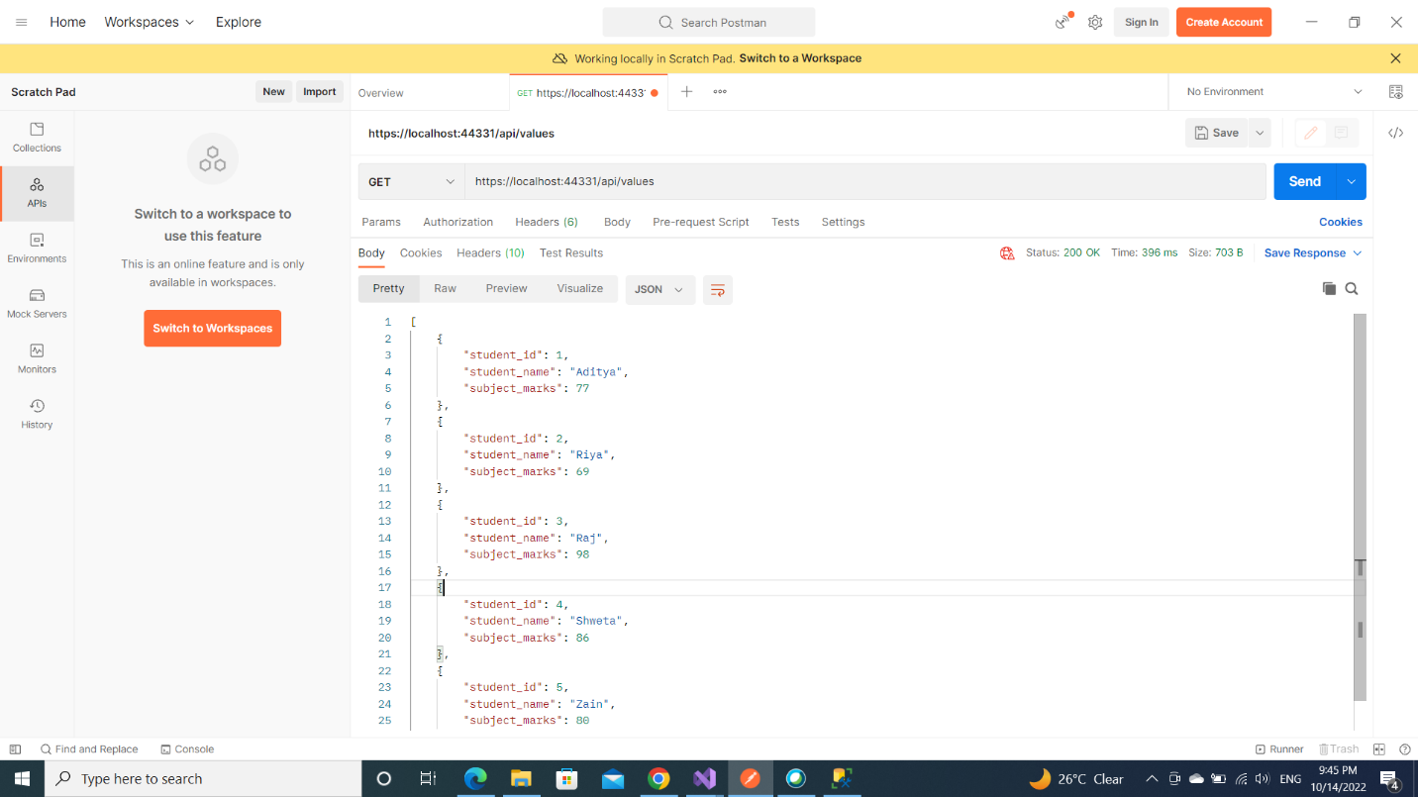

1. Update

1. Add

1. Delete

